LAB REPORT实验报告
Lab Title | Binary Tree |  |  |  | Lab No.
Stud. Name | 蒋云翔 | Major | CST |  | Class
Student ID | 2022102330 |  | Date | 2023/10/09
Lab description/objectives:
Input the pre-order traversal sequence of a binary tree, where * represents virtual node (i.e. the node does not exist, NULL link), for example ABD***CE**F**. (Also consider the example: ABC*D*E***F**.)
Complete the following tasks:
1. Program to create the linked representation of the binary tree base on the
inputted pre-order traversal sequence.
2. Program to traverse the binary tree iteratively and output the traversal
sequences with pre-order, in-order and post-order traversals.
3. Program to count the total number of the nodes in the tree
4. Program to count the number of the leaves of the tree
5. Output the binary tree with the string representation
6. Program to delete the tree.
Source code:
#include<stdio.h>
#include <stdbool.h>
#include <stdlib.h>

#define MaxSize 100

typedef struct node {
char data;
struct node* lchild, * rchild;
}BinTNode; //define the data type of the node

typedef BinTNode* BinTree;

BinTree CreatBinTree() {
BinTree T;
char ch;
if ((ch = getchar()) == '*')
return(NULL); /*input is ‘*’，return null vector*/
else {
T = (BinTree)malloc(sizeof(BinTNode)); /*create a node*/
T->data = ch;
T->lchild = CreatBinTree(); /*create the left subtree*/
T->rchild = CreatBinTree(); /*create the right subtree*/
return T;
}
}

void deleteBt(BinTree* b) //传入的是Bt节点的地址，将free后的节点指向地址设为NULL，方便确定已经删除干净
{
if (*b == NULL) return;
deleteBt(&((*b)->lchild));
deleteBt(&((*b)->rchild));
free(*b);
*b = NULL;
}

int count(BinTree b) //利用递归来找到node 让num++ 最后计算出node总数
{
static int sum = 0;
if (b) {
count(b->lchild);
count(b->rchild);
sum++;
}
return sum;
}

int countleaf(BinTree b) //与count函数类似 补充一个判断是否是leaf node的条件
{
static int sum1 = 0;
if (b) {
countleaf(b->lchild);
countleaf(b->rchild);
if(b->lchild == NULL && b->rchild == NULL) sum1++;
}
return sum1;
}

void PreOrder(BinTree b)
{
BinTNode* St[MaxSize];
BinTNode* p;
int top = -1;
bool flag;
if (b != NULL)
{
do
{
while (b != NULL)
{
printf("%c", b->data); //先root 再left 再right
top++;
St[top] = b;
b = b->lchild;
}
p = NULL;
flag = true;
while (top != -1 && flag)
{
b = St[top];
if (b->rchild == p)
{
top--;
p = b;
}
else
{
b = b->rchild;
flag = false;
}
}
} while (top != -1);
printf("\n");
}
}

void InOrder(BinTree b) { //先left 再root 再right
BinTNode* St[MaxSize];
BinTNode* p;
int top = -1;

if (b != NULL) {
do {
while (b != NULL) {
top++;
St[top] = b;
b = b->lchild;
}

if (top != -1) {
p = St[top];
top--;
printf("%c", p->data);
b = p->rchild;
}
} while (top != -1 || b != NULL);

printf("\n");
}
}

void PostOrder(BinTree b)//先left 再right 再root
{
BinTNode* St[MaxSize];
BinTNode* p;
int top = -1;
bool flag;
if (b != NULL)
{
do
{
while (b != NULL)
{
top++;
St[top] = b;
b = b->lchild;
}
p = NULL;
flag = true;
while (top != -1 && flag)
{
b = St[top];
if(b->rchild == p)
{
printf("% c", b->data);
top--;
p = b;
}
else
{
b = b->rchild;
flag = false;
}
}
} while (top != -1);
printf("\n");
}
}

void DispBinTree(BinTree b)
{
if (b != NULL)
{
printf("%c", b->data);
if (b->lchild != NULL || b->rchild != NULL)
{
printf("(");
DispBinTree(b->lchild);
if (b->rchild != NULL) printf(",");
DispBinTree(b->rchild);
printf(")");
}
}
}

void judge(BinTree b) //判断是否删除干净
{
if (b == NULL) printf("Empty Binary Tree!!\n");
}

int main()
{
BinTree bt = CreatBinTree();
int num = count(bt);
int num1 = countleaf(bt);
printf("Your Binary Tree is:");
DispBinTree(bt);
printf("\n");
printf("PreOrder:");
PreOrder(bt);
printf("InOrder:");
InOrder(bt);
printf("PostOrder:");
PostOrder(bt);
printf("The number of nodes are:%d\n", num);
printf("The number of leaf nodes are:%d\n", num1);
deleteBt(&bt);
printf("Successfully delete the Tree!!\n");
judge(bt);
return 0;
}
Program outputs:
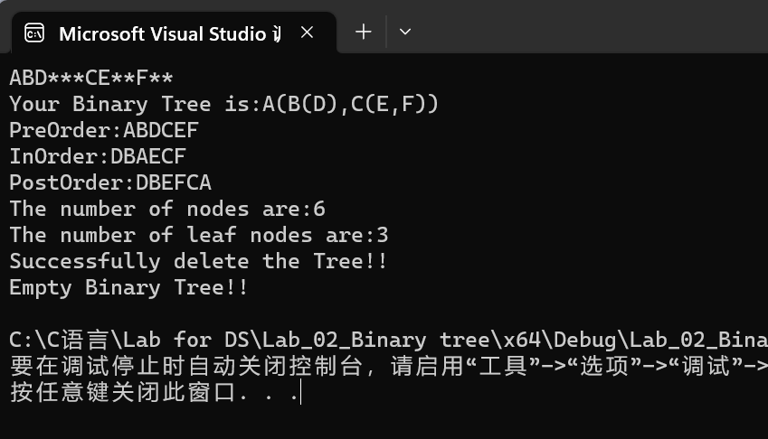
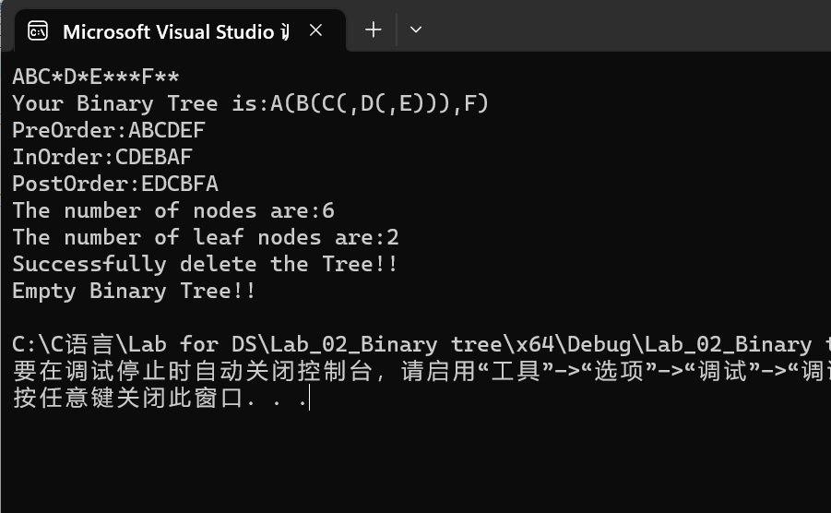

Analysis:
Time complexity of each function:
- CreatBinTree: O(n) （n is the number of the nodes of the tree!!!）
- deleteBt: O(n)
- count: O(n)
- countleaf: O(n)
- PreOrder: O(n)
- InOrder: O(n)
- PostOrder: O(n)
- DispBinTree: O(n)

